**Kappata, Stephen** (1936-2007)

Stephen Chipango Kappata was born in Zambia in 1936 to Angolan migrant parents who fled Angola during the Portuguese wars of conquest during the First World War. Kappata began painting in 1969-1970 following a meeting with an artist who sold paintings depicting Victoria Falls to the local tourist market. At first Kappata sold his paintings to a mainly local market centred around the town of Mongu. Following a brief period abroad in Britain where he received some training in film, photography and illustration, Kappata returned to Zambia where in 1982 he met a Danish woman called Anna-Lise Clausen who helped organise Kappata’s first solo exhibition at the Mpapa Gallery in 1986. Stephen Kappata went on to take part in numerous international shows including the Third Havana Biennial in Cuba in 1989. Kappata’s work is a complex interplay between satire and education, his paintings broadly cover three main themes: Zambians traditions, customs and culture; the historical experience and injustice of colonialism, and the social commentary on contemporary issues including alcoholism, AIDS, sexual promiscuity and workers’ rights. Although Kappata’s work was in many ways marketed by a western driven African art market as ‘naïve’, ‘self-trained’ and ‘folkloristic’, today his paintings stand out as an important testament of Zambian and South African political and social history.

Kappata’s father was a migrant labourer and woodcarver who made drums, mortars and baskets. Stephen was the only child out of seven pregnancies to survive, and he was brought up in the Watchtower faith, a popular movement especially among migrant communities in the Baroseland district during the 1930s, which was considered suspiciously anti-European and anti-nationalistic both by the British colonialists and later by independent African nations alike. Stephen Kappata began drawing in primary school despite receiving no formal art education or training. After completing his primary education, he worked as a cleric in Zambia and a labourer in the gold mines in South Africa in 1960 during the great political upheaval following the massacre of Sharpeville. In 1962, Kappata returned home to witness the collapse of the Federation of Rhodesia and Nyasaland and the birth of the independent nations of Zambia and Malawi. For a short period Kappata became secretary and then chairman of the United National Independence Party (UNIP), but his political career ended due to the conflict with his family’s beliefs.

Further Reading:

Hugh Macmillan The Life and Art of Stephen Kappata

Source: African Arts, Vol. 30, No. 1 (Winter, 1997), pp. 20-31+93-94

Stable URL: http://www.jstor.org/stable/3337469 .Accessed: 28/02/2014 08:46

Image:

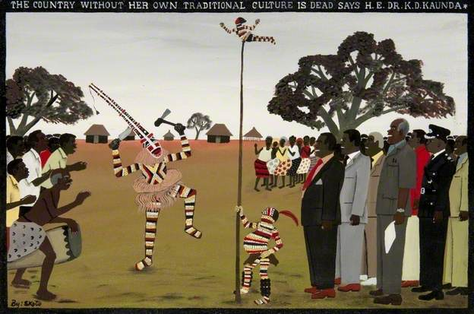

<http://ichef.bbci.co.uk/arts/yourpaintings/images/paintings/gm/624x544/gl_gm_a_1990_41_624x544.jpg>

Title: Likishi

Oil on Canvas, 46 x 68.5 cm

Collection: Glasgow Museums